Task 21

# Deep Das

1. You need to draw a dual axis-plot in one show sin(x) and in other show cos(x) with

range 0 to 4pi.

Answer :

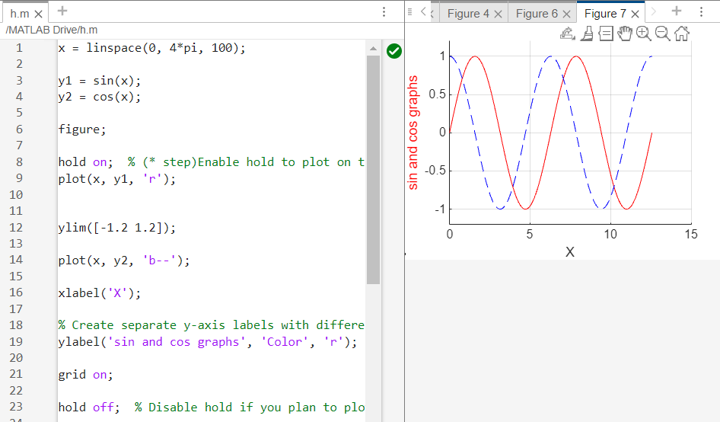

2. Plot functions y = x, y = x2, y = x3 where x belongs 0 to 10.

Answer:

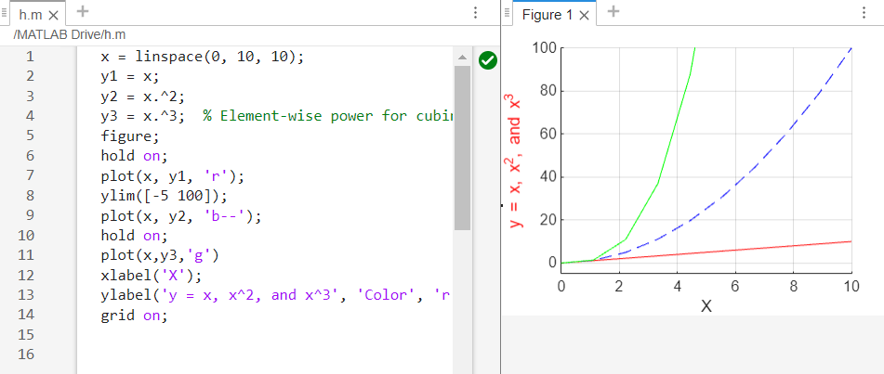

3. Plot a Bar chart a, b, c with values {1,2,3}, {4,5,6}, {7,8,9} .

Answer:

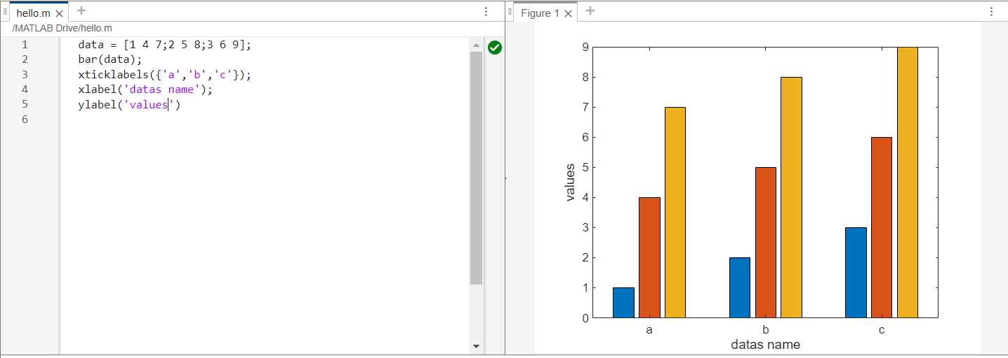

4. Plot a Pie chart a, b, c, d with percentages 15,30,45,10 respectively.

Answer:

